Physical Library  10,000 Books  Audiobooks  DVDs  Newspapers  Magazines | Virtual Library  15,000 eBooks  Databases  Newspapers/Magazines  Academic Journals  Videos, etc.
Please note: If you want/need something we don’t have, just ask and we will get it for you

Today in Class:

A. Pauluslibrary.weebly.com
Search Ranney Resources tab -> Everything, In the Library, Databases

B. Browse the two specific databases:
Issues
-click Topics to see a full list
-Once you’ve selected a topic, use the Topics navigation on the left to go deeper.

Points of View
-click Show All to see a full list
-Once you’ve selected a topic, use the Related Items to go deeper.

*If ever asked to sign in from home, please use ranney/library as username/password.

C. Select a few (more than two) possible topics:

1.______________________________________________________________

2.______________________________________________________________

3.______________________________________________________________

4.______________________________________________________________

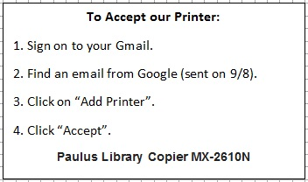
D. Take a quick quiz: Works Cited Multiple Choice.

