Logging in to Turnitin via Google SSO

- Navigate to the Turnitin login page: https:/www.turnitin.com/login_page.asp
- Select the Sign in with Google button.
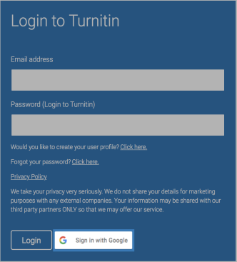

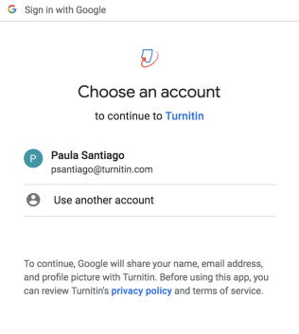
- You will be asked which Google account you want to authenticate with. Choose your Ranney account.

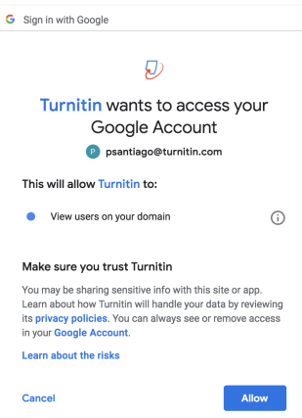
- You will be asked to give Turnitin access to your Google account. Click the Allow button.

That’s it! From now on, use only your Ranney Google credentials to sign in to Turnitin.

